Day_2_AT_Asymmetric Crypto
Cybersecurity Training - Day 2 Notes
1. Introduction to Asymmetric Cryptography
Limitations of Symmetric Cryptography
Key Distribution Problem: Sender and receiver must share same secret key
Requires secure channel for initial key exchange
Impossible for parties without prior relationship
Scalability Issue: For n parties to communicate, need n(n-1)/2 keys

The Historical Challenge
Traditionally required secure physical channels for key exchange:
Paper key lists transported by trusted courier
Physical meetings to exchange keys
Problem: Physical channels not always available or practical

2. Fundamentals of Public-Key Cryptography
Core Concept
Each user has a key pair: public key + private key
Public Key (PubK): Can be freely shared with anyone
Private Key (PrivK): Must be kept secret by owner

Security Objective
Breaking public-key cryptography = solving mathematical problems
Common metric: key size
Larger key size → More security but less efficiency
Security depends on difficulty of underlying mathematical problem

Computational Complexity Considerations
Time to break = f(key size) where f is algorithm complexity
Need to know best existing algorithm to choose appropriate key size
Current target: Security equivalent to 2¹²⁸ operations

Key Mathematical Problems
Integer Factorization Problem (RSA)
Easy to multiply large primes
Hard to factor the product back to primes
Discrete Logarithm Problem (ElGamal, DSA, ECDSA)
Easy to compute h = gˣ given x
Hard to find x given h and g

Best Known Algorithms
Factoring: Number Field Sieve (NFS)
Current computing capability: ~2⁸⁰ to 2¹⁰⁰ operations
Future growth: Approximately 2^(100 + 0.66k) in k years

3. How Asymmetric Cryptography Works
Confidentiality (Encryption)
Encrypt with recipient's public key
Decrypt with recipient's private key
Result: Only intended recipient can read the message

Integrity & Authentication (Digital Signatures)
Sign with sender's private key
Verify with sender's public key
Result: Verifies message came from claimed sender and wasn't altered

Combined Confidentiality & Integrity
Can combine both for secure, authenticated communication

4. RSA Algorithm (Rivest-Shamir-Adleman)
Historical Context
Invented in 1978 by Rivest, Shamir, Adleman
Actually discovered in 1973 by Clifford Cocks (British intelligence)
Most popular public-key cryptosystem

Key Generation Steps
Step 1: Select Primes
Choose two large prime numbers p and q
Typically similar size, hundreds of digits long
Step 2: Compute Modulus
n = p × q (this is the modulus)
φ(n) = (p-1) × (q-1) (Euler's totient function)
Step 3: Choose Public Exponent
Select e such that:
1 < e < φ(n)
gcd(e, φ(n)) = 1 (coprime)
Common choices: 3, 17, 65537
Step 4: Compute Private Exponent
Find d such that: e × d ≡ 1 mod φ(n)
d is the modular multiplicative inverse of e modulo φ(n)

Resulting Keys
Public Key: (e, n)
Private Key: d (p and q must also be kept secret or discarded)

Encryption & Decryption
Encryption: C = Mᵉ mod n (M is message, C is ciphertext)
Decryption: M = Cᵈ mod n

Security Basis
From n, difficult to compute p and q (factoring problem)
From (n, e), difficult to compute d
From (n, e) and C, difficult to compute M

5. RSA Example
Small-Scale Example
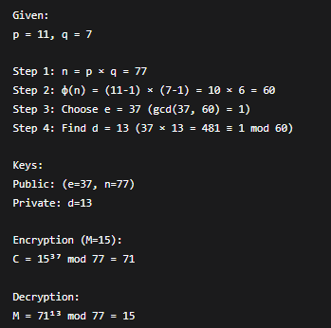
Practical Exercise (From Slides)
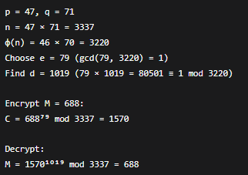

6. RSA Security Considerations
Key Size Recommendations
700-bit: Factored in 2007
768-bit: Factored in 2009
1024-bit: Minimal security today (likely breakable soon)
2048-bit: Current recommended minimum
15360-bit: NIST suggestion for long-term security

Potential Threats
Mathematical breakthroughs in factoring algorithms
Quantum computers using Shor's algorithm
Implementation flaws rather than algorithm weaknesses

7. Performance Characteristics
Efficiency Issues
Asymmetric crypto is computationally expensive
Much slower than symmetric cryptography
RSA speed is quadratic in key length
Not suitable for real-time or bulk encryption

Hybrid Approach Solution
Use asymmetric crypto to exchange symmetric key securely
Use symmetric crypto with shared key for actual data transfer
Best of both worlds: Security of asymmetric + speed of symmetric

8. Digital Signatures
Concept
Electronic equivalent of handwritten signatures
Provides: Authentication, data integrity, non-repudiation
Cannot be forged (without private key)
Cannot be denied by signer (non-repudiation)

How They Work
Signing: Hash message, encrypt hash with private key
Verification: Decrypt signature with public key, compare with message hash

Common Pattern with Hash Functions
Compute hash of message: h = H(M)
Sign the hash: S = hᵈ mod n
Send (M, S)
Verifier computes h' = H(M)
Verifier computes h'' = Sᵉ mod n
If h' = h'', signature is valid

9. Public Key Infrastructure (PKI)
The Trust Problem
How do we know a public key really belongs to claimed entity?
Anyone can generate key pair and claim any identity
Digital signatures only tie messages to keys, not to people

PKI Solution
Certificate Authority (CA): Trusted third party that vouches for identities
Digital Certificate: Binds public key to identity
Registration Authority (RA): Verifies identities for CA
Validation Authority (VA): Stores and validates certificates

Certificate Components
Subject's public key
Subject's identity information
Issuer (CA) information
Validity period
Digital signature of CA
X.509 Standard
Most widely accepted certificate format
Version 3 is current standard
Used by SSL/TLS, IPSec, SET, and many applications

10. PGP and GPG
Pretty Good Privacy (PGP)
Protocol for encryption and digital signatures
Hybrid cryptosystem: Combines symmetric and asymmetric crypto
Used for email, files, directory encryption
Web of Trust model (decentralized verification)

GNU Privacy Guard (GPG)
Free implementation of OpenPGP standard
Command-line tool for encryption/signing
Supports S/MIME and SSH
Widely used for software distribution verification

11. Trust Models
Hierarchical PKI (Centralized Trust)
Root CAs at top of hierarchy
Chain of certificates back to trusted root
Vulnerability: Compromise of root CA affects entire system
Used by most web browsers and organizations

Web of Trust (Decentralized)
Everyone can act as certificate authority
Users sign each other's keys
Builds network of trusted relationships
Used by PGP/GPG community

12. Practical Considerations
Obtaining Certificates
Self-signed: Create your own (not trusted by others)
Commercial CAs: VeriSign, Thawte, DigiCert, etc.
Free CAs: Let's Encrypt, SSL.com
Organizational CAs: Internal PKI for companies

Certificate Lifecycle Management
Generation: Create key pair and CSR
Issuance: CA signs and issues certificate
Validation: Verify certificate chain
Renewal: Before expiration
Revocation: If compromised (CRL/OCSP)
Expiration: Automatic invalidation

Common Vulnerabilities
Weak random number generation for keys
Implementation flaws in cryptographic libraries
Social engineering attacks against CAs
Failure to revoke compromised certificates
Misconfigured certificate validation

13. Real-World Applications
Secure Web Browsing (HTTPS/SSL/TLS)
Uses RSA for key exchange
Combines with symmetric encryption for data transfer
Certificates verify website identity

Secure Email (S/MIME, PGP)
Encrypt email content
Digitally sign messages
Verify sender authenticity

Code Signing
Verify software authenticity
Prevent tampering with downloads
Used by Windows, macOS, Linux package managers

VPNs and Remote Access
Authenticate users and devices
Establish secure tunnels
Combine with symmetric encryption

Blockchain and Cryptocurrencies
Digital signatures for transaction authorization
Public keys as wallet addresses
Proof of ownership without revealing identity

14. Comparison Summary

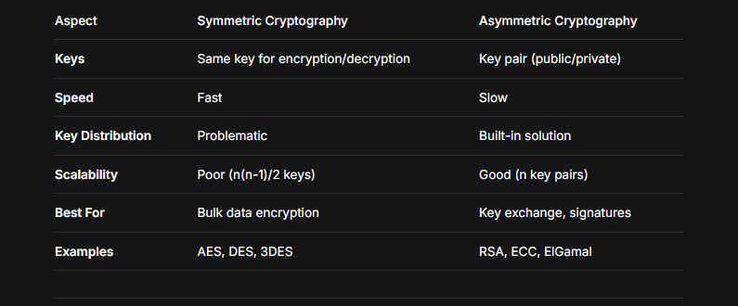

15. Future Considerations
Quantum Computing Threat
Shor's algorithm can break RSA and ECC
Need for post-quantum cryptography
NIST standardization process ongoing
Candidate algorithms: Lattice-based, code-based, multivariate

Current Best Practices
Use 2048-bit RSA minimum (3072 or 4096 for long-term)
Consider Elliptic Curve Cryptography (ECC) for efficiency
Always combine with symmetric crypto for data encryption
Regularly update cryptographic libraries
Monitor for new vulnerabilities and attacks

Hybrid Cryptographic Systems
Most real-world systems use:
Asymmetric crypto for:
Key exchange
Digital signatures
Authentication

Symmetric crypto for:
Bulk data encryption
Real-time communication
Database encryption

16. Review Questions
Conceptual:
What problem does asymmetric cryptography solve that symmetric cryptography cannot?
Explain the difference between public and private keys.
Why is RSA secure? What mathematical problem protects it?
What are the advantages and disadvantages of asymmetric cryptography?
How do digital signatures provide non-repudiation?

Practical:
Generate RSA keys with p=17, q=19, e=5. Find d and encrypt M=88.
Explain the steps to verify a digital signature.
What happens if a CA's root certificate is compromised?
Why do we typically use hybrid cryptosystems instead of pure asymmetric crypto?
How does PGP's web of trust differ from hierarchical PKI?

Analytical:
If quantum computers become practical, which cryptographic algorithms are most at risk?
Why is 1024-bit RSA no longer considered secure for long-term use?
How can you tell if a website's certificate is valid and trustworthy?
What are the trade-offs between key size and performance in RSA?
How do certificate revocation lists (CRLs) work, and what are their limitations?

17. Summary of Key Points
Asymmetric Cryptography Fundamentals:
Solves key distribution problem of symmetric crypto
Based on hard mathematical problems (factoring, discrete log)
Uses key pairs: public key (shared) and private key (secret)
Slower but more flexible than symmetric crypto

RSA Algorithm:
Most widely used public-key algorithm
Security based on difficulty of factoring large numbers
Requires large key sizes for security (2048-bit minimum)
Used for key exchange and digital signatures

Digital Signatures & PKI:
Provide authentication, integrity, non-repudiation

Require trusted third parties (Certificate Authorities)
X.509 standard defines certificate format
Hybrid approach common: RSA for key exchange, AES for data

Best Practices:
Use appropriate key sizes for security requirements
Implement proper certificate validation
Combine asymmetric and symmetric cryptography
Stay updated on cryptographic vulnerabilities
Plan for post-quantum cryptography transition

